

**Experiment No. 8**

**Title:** Password Cracking - Burp suite

**Batch: B-2 Roll No.: 16010422234 Experiment No.: 8**

**Aim:** To implement password cracking using Burp suite

**Procedure / Approach /Algorithm / Activity Diagram:**

1. **Installation of Burp suite and other utilities (open source/ freeware/ trial versions)**
2. **Perform password cracking using Burp suite (refer to sample video uploaded)**

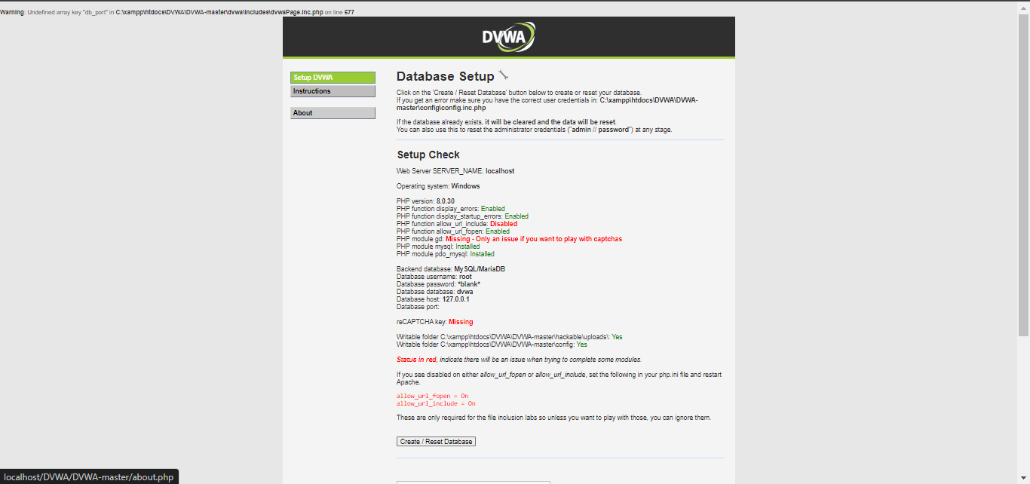

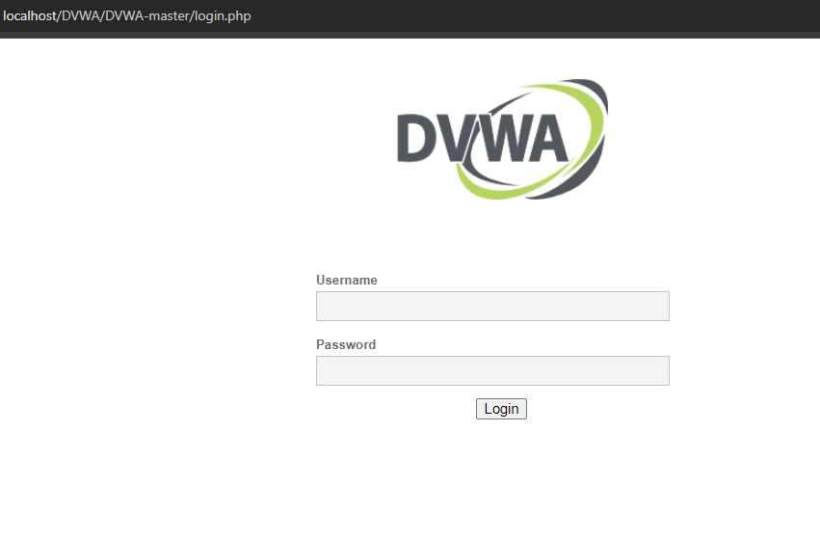

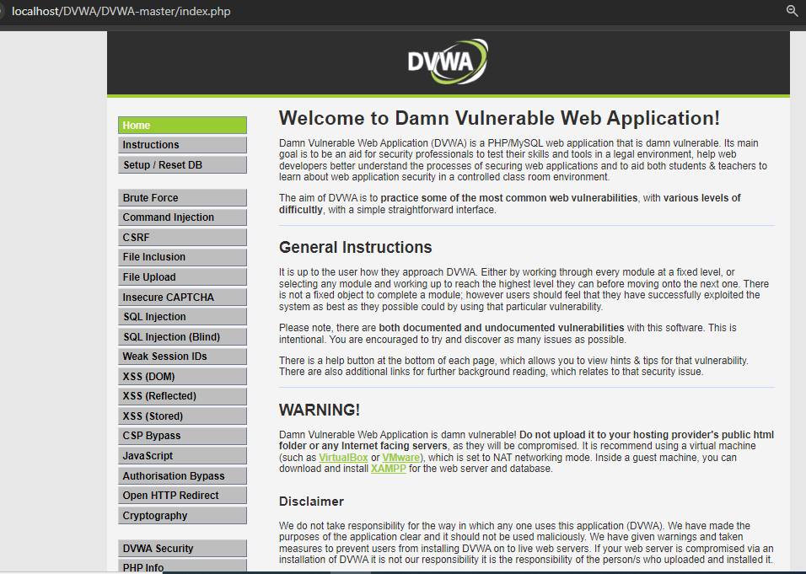

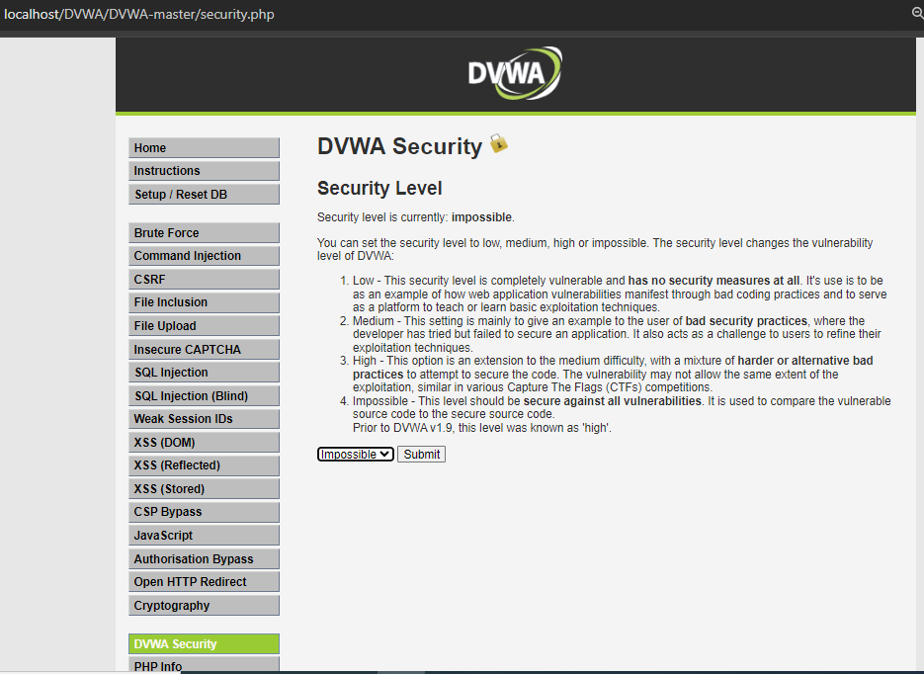

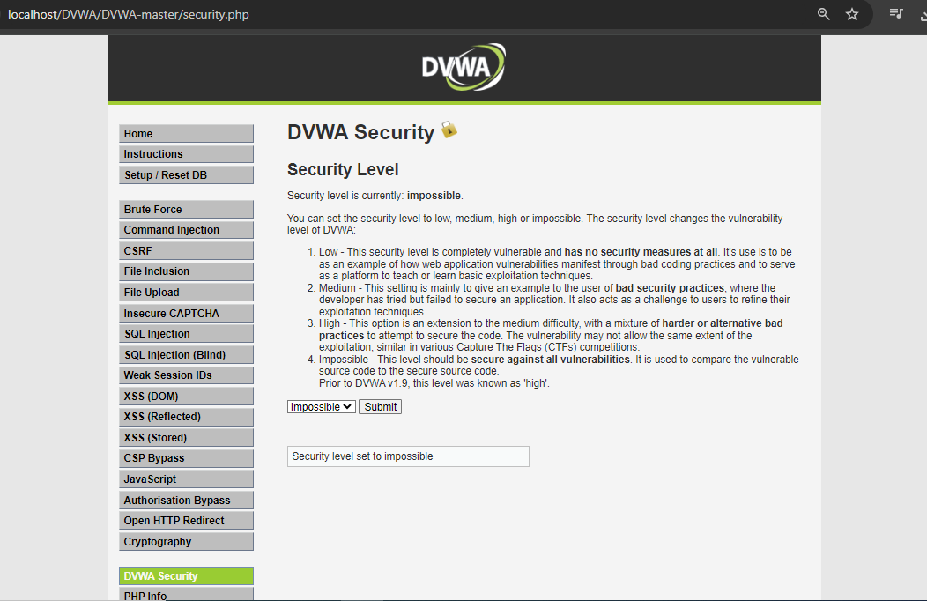

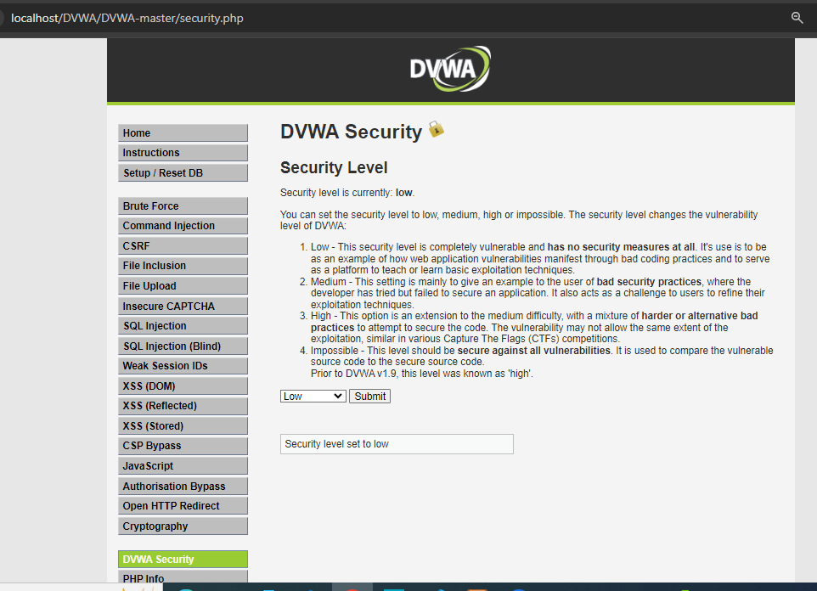

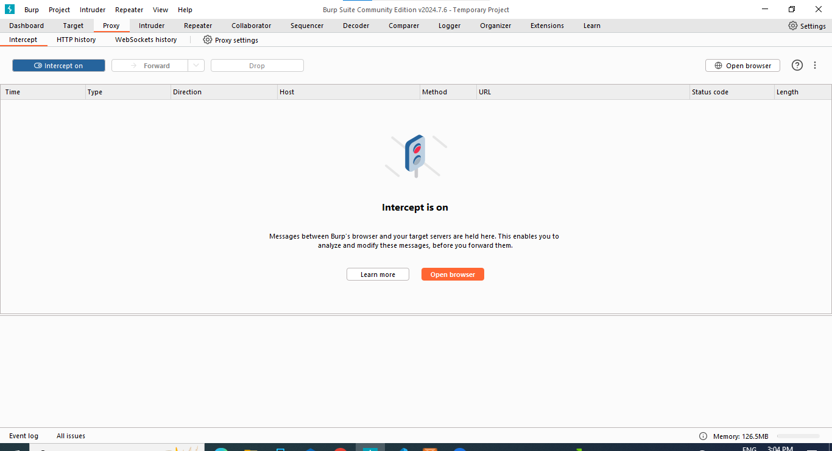

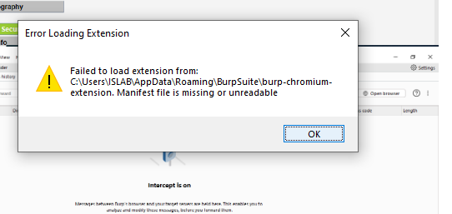

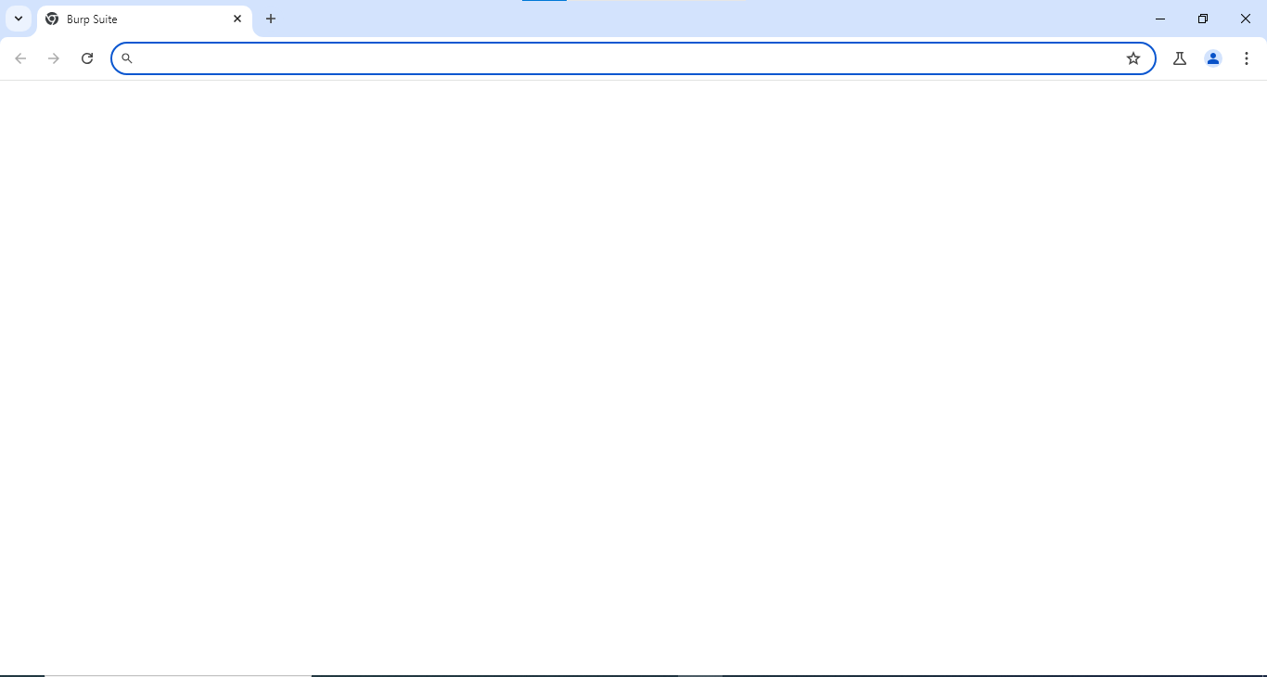

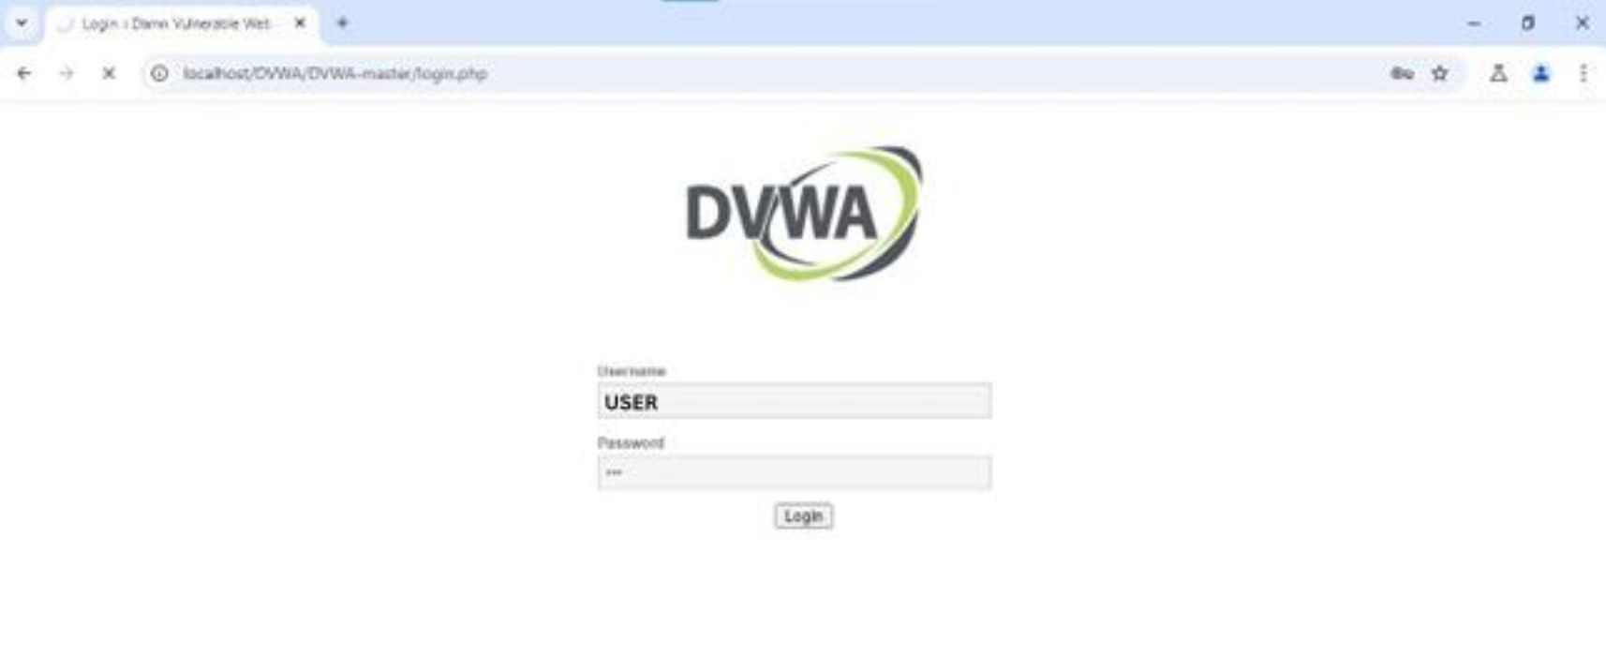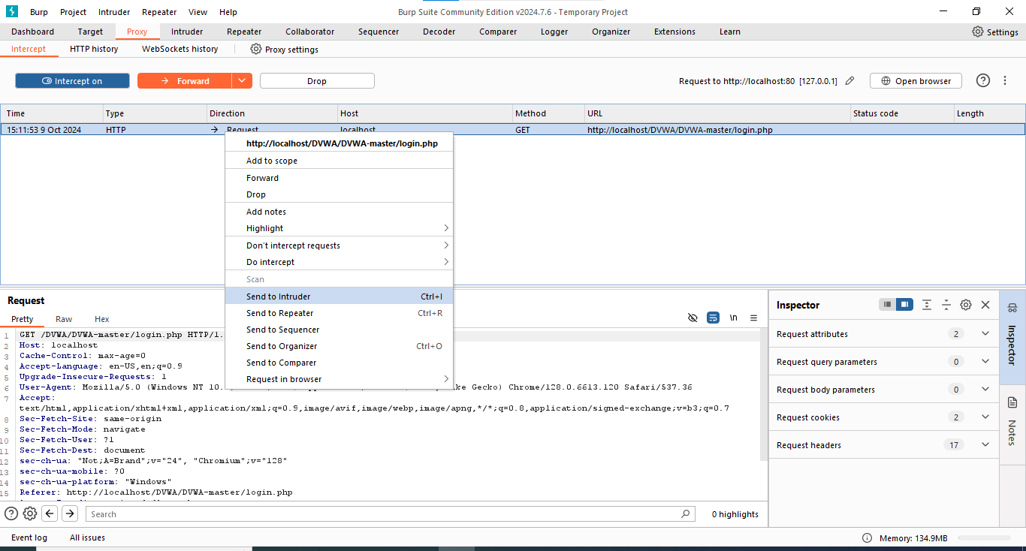

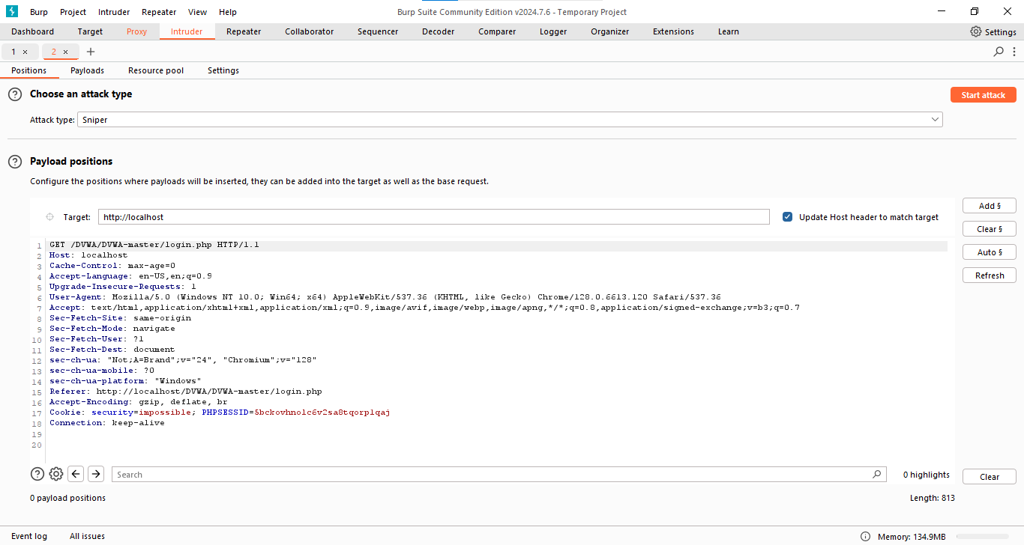

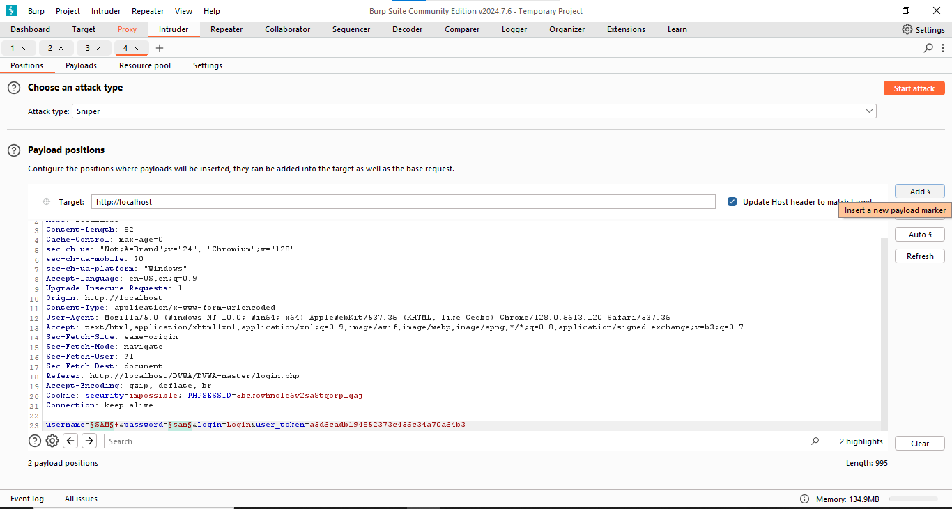

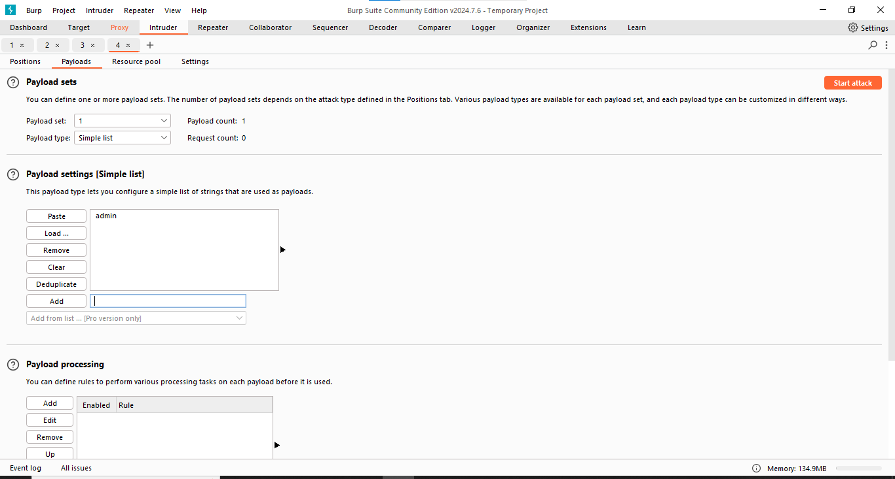

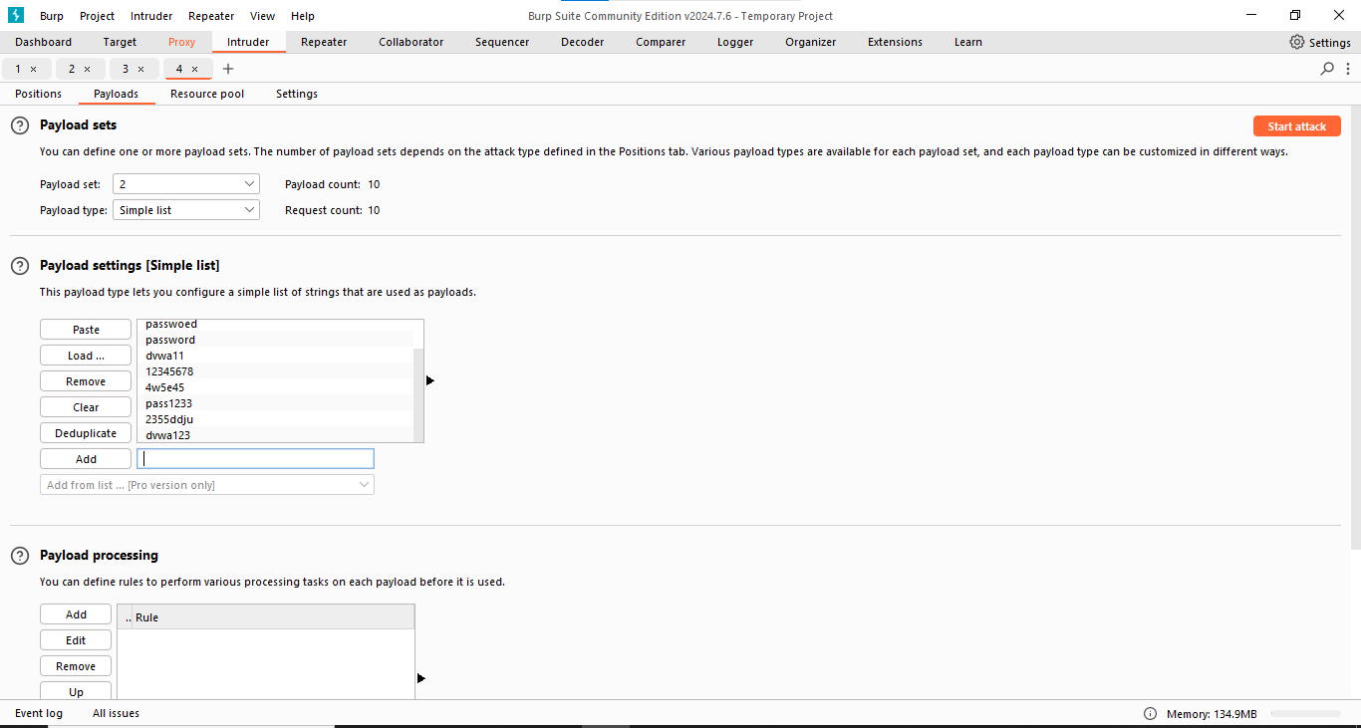

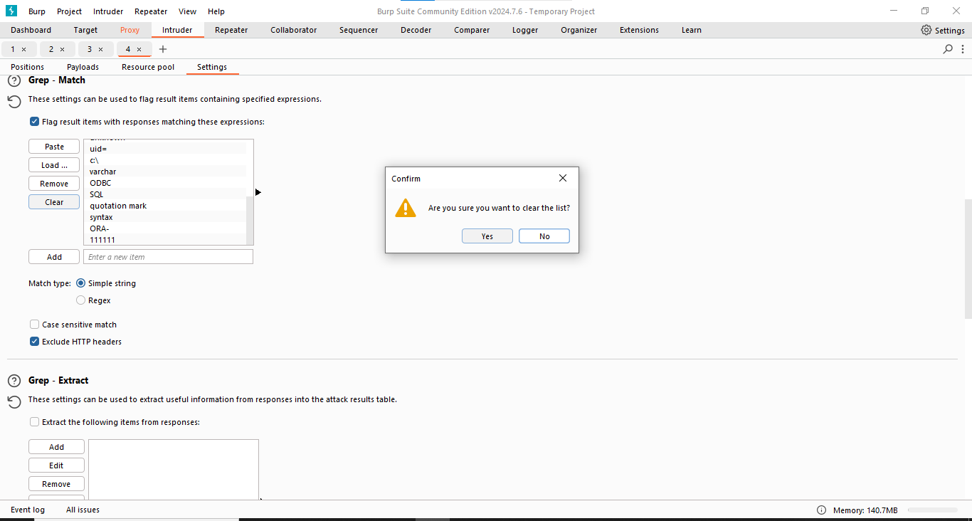

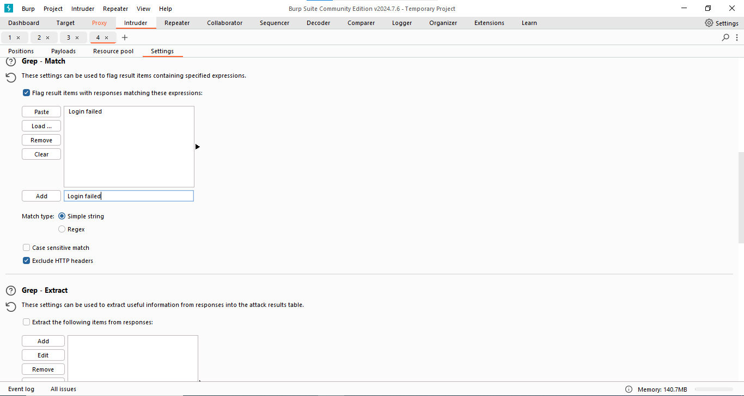

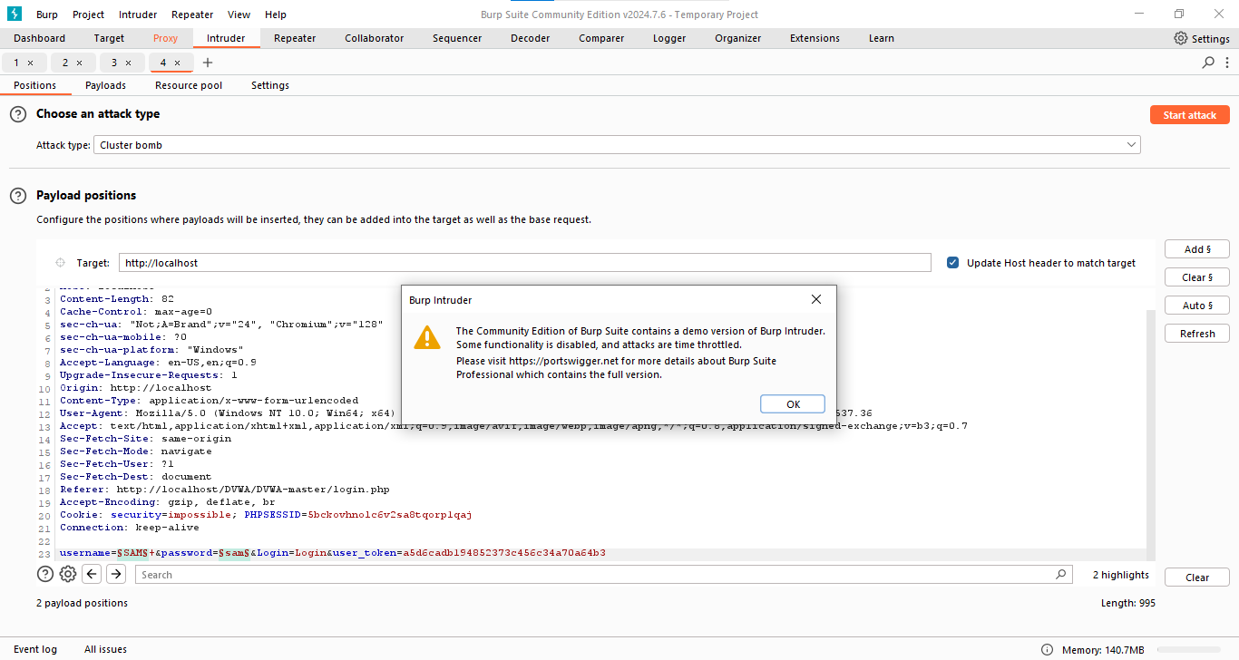

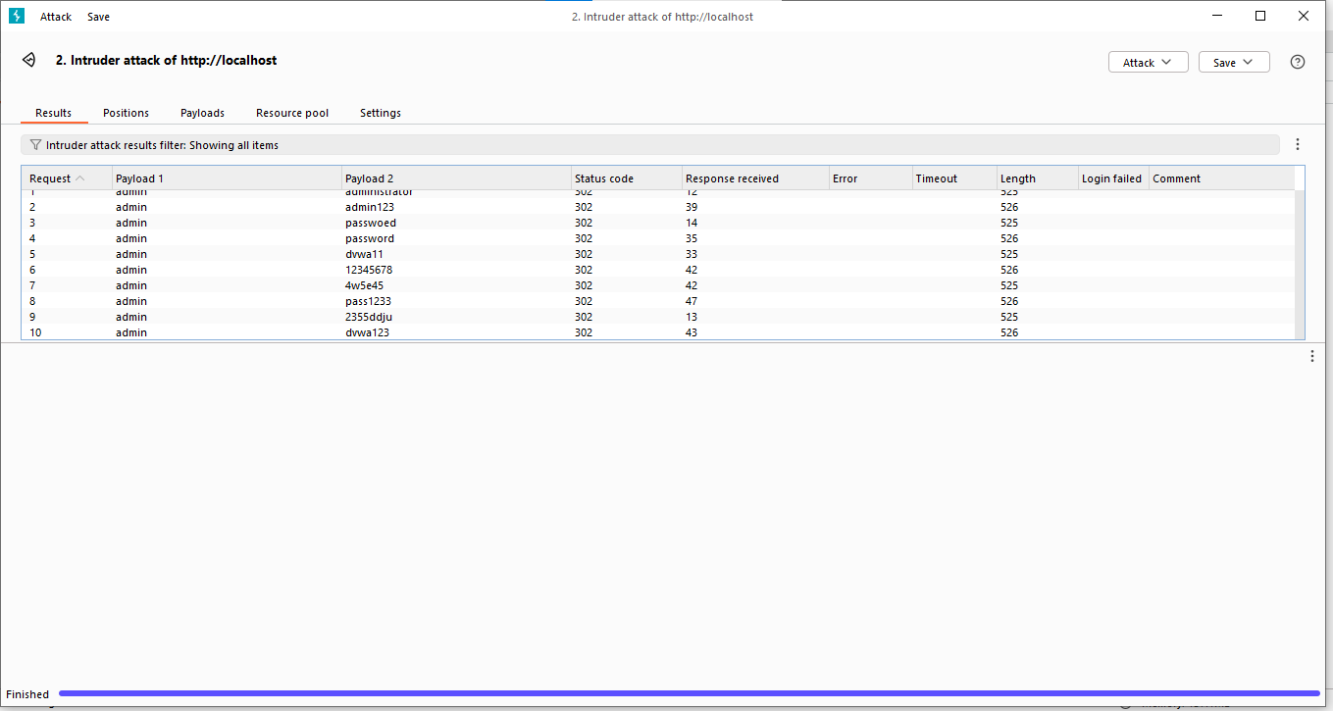

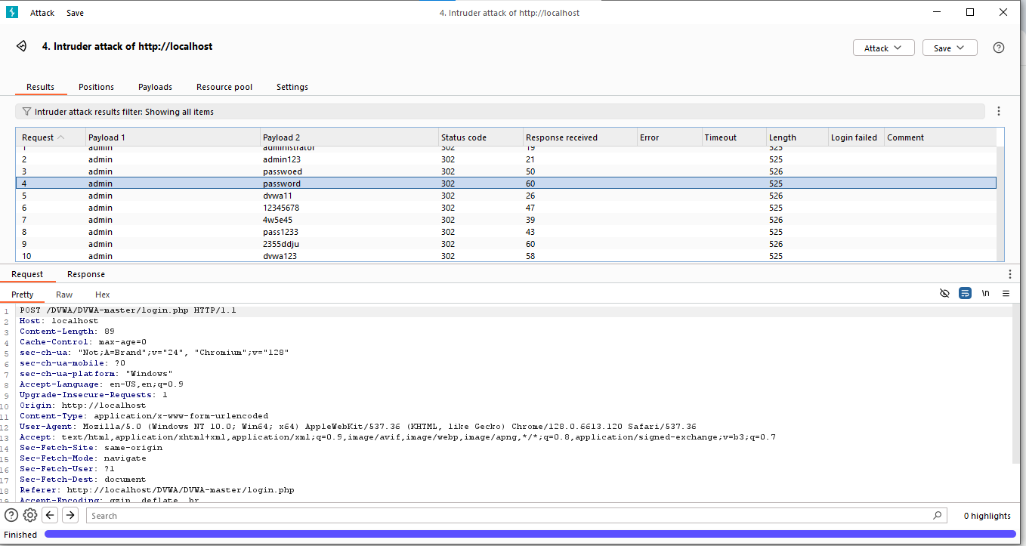

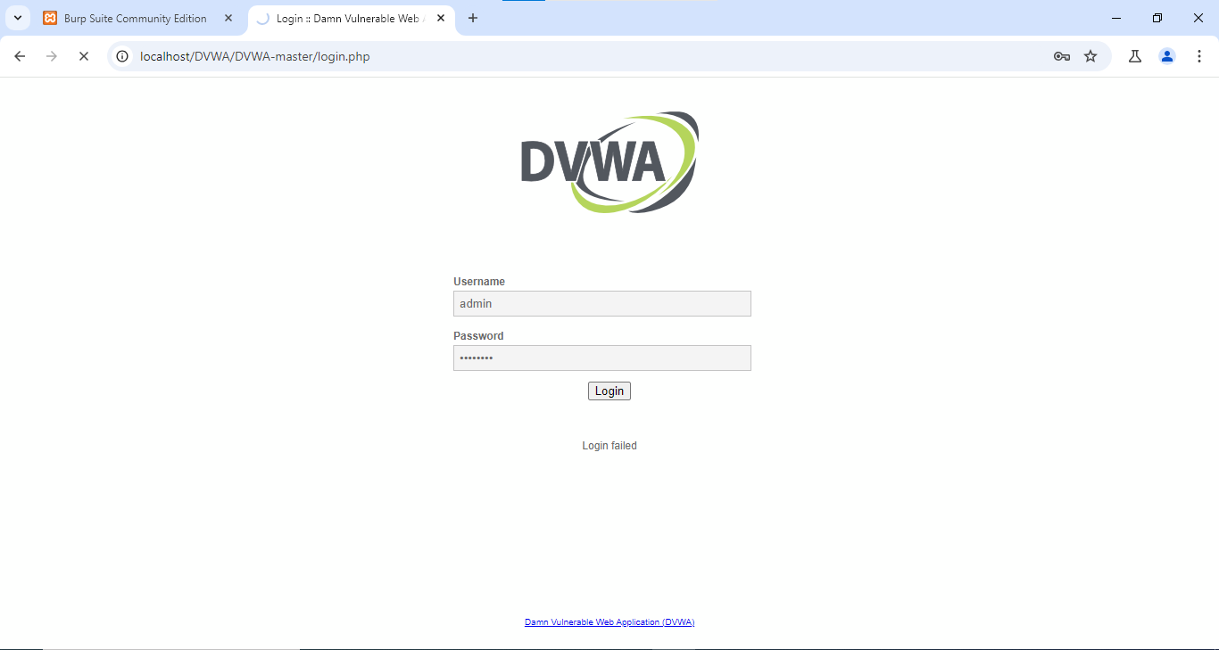

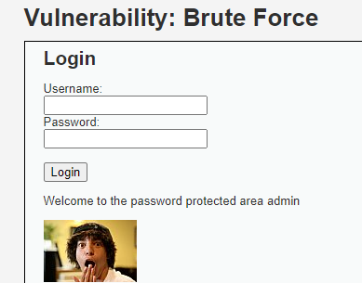

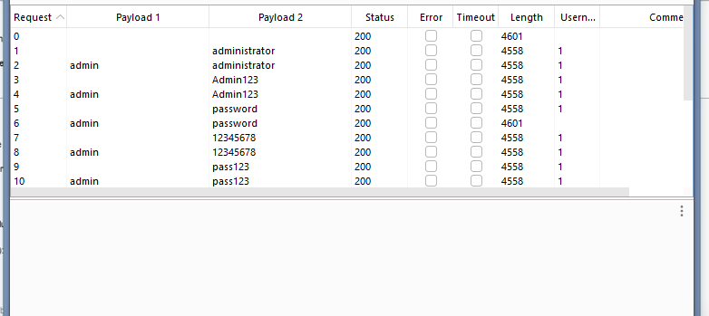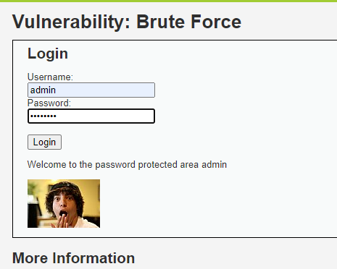

Implementation: Audio-Video recording of the mentioned activities performed with your own voice. (upload .mp4 file along with final writeup)



**Questions:**

1) Explore any other use of Burp suite. Perform it using burp suit and add the screen shots of the same.

Ans -

Now we try vulnerability.  
XSS

Cross-site Scripting

Open bWAPP   
Keep interceptor on

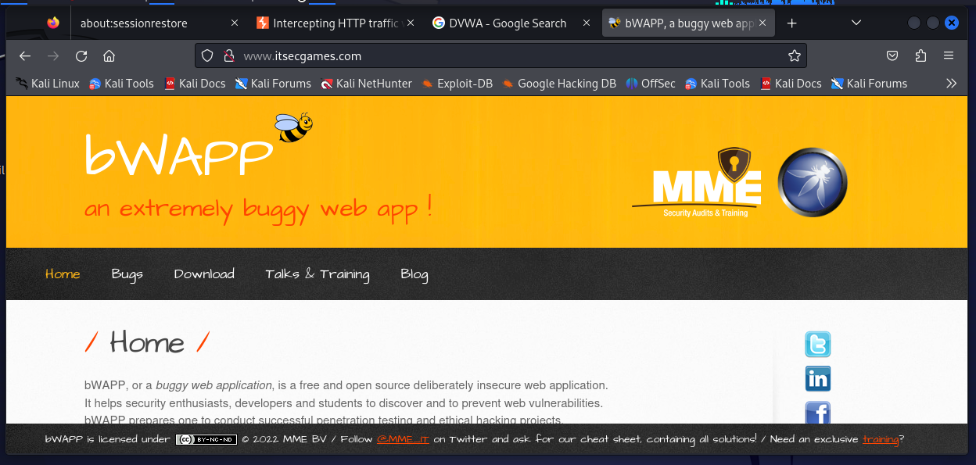

Bwapp is a low security buggy web application

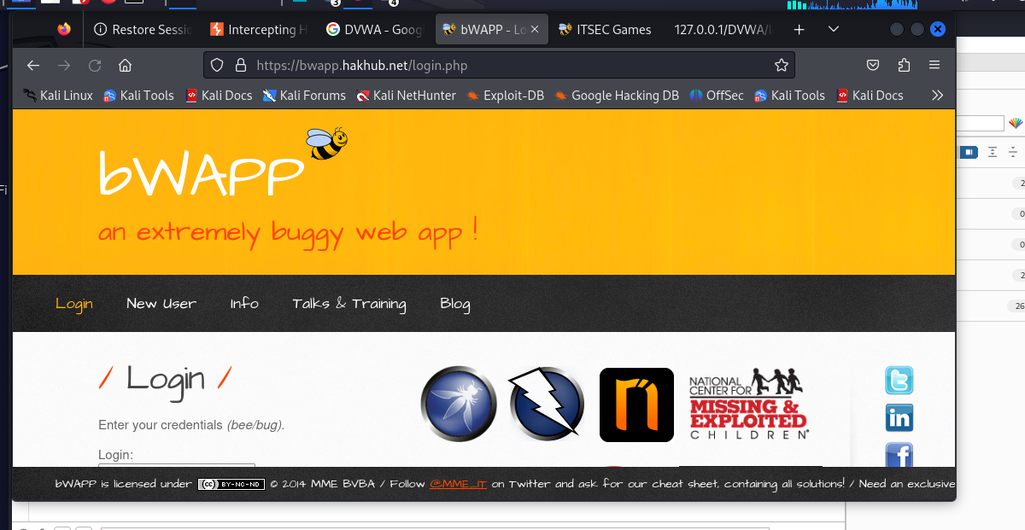

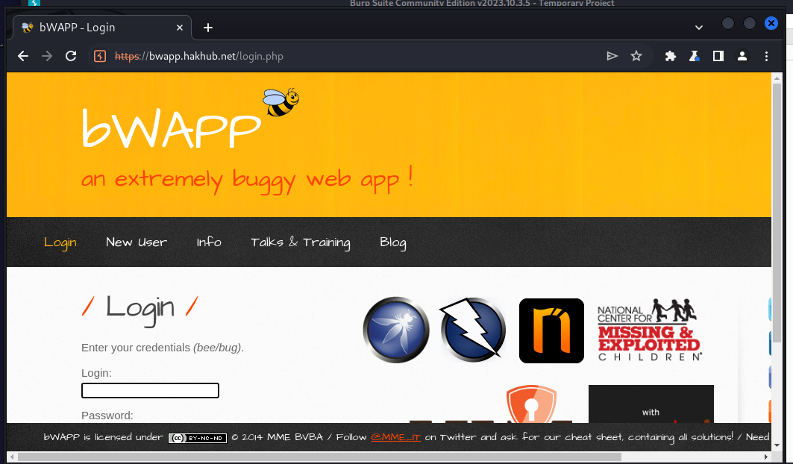

Keep intercept on and enter login and password

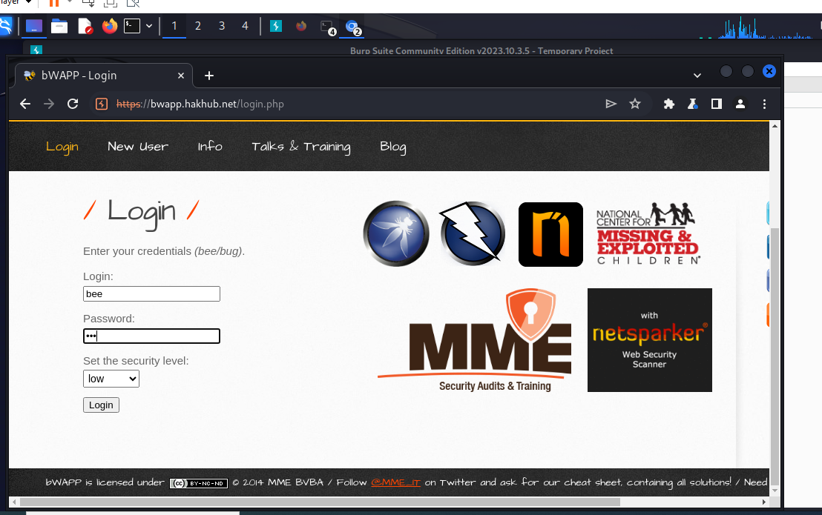

Send proxy to intruder

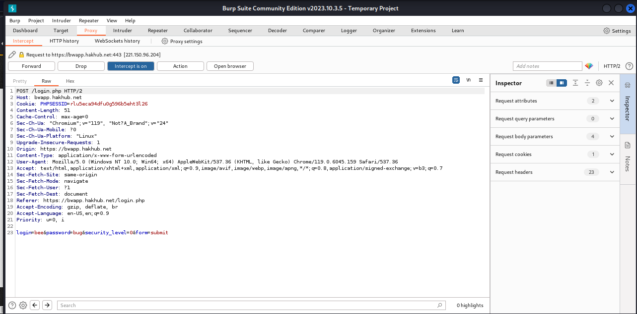

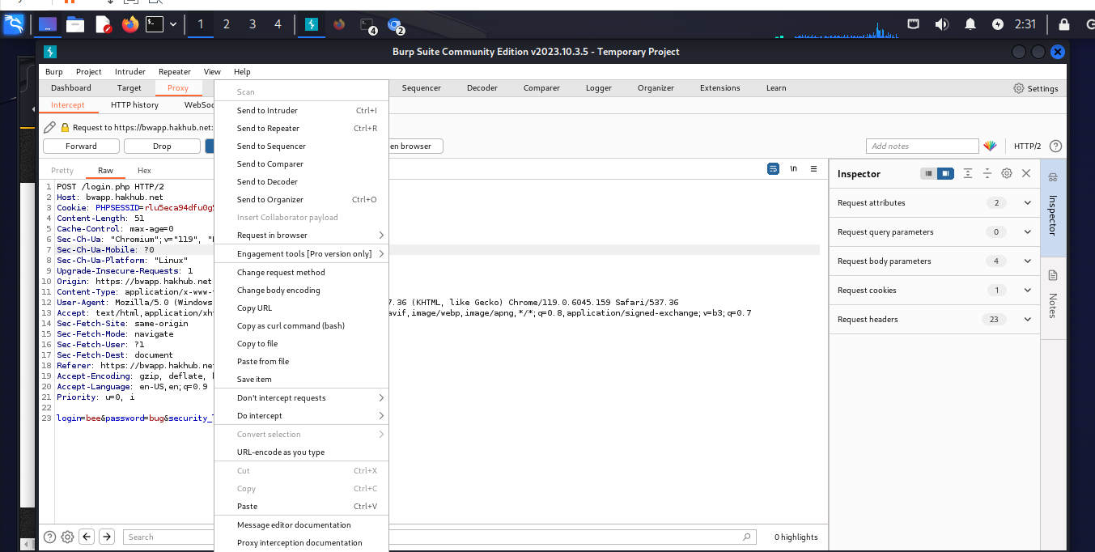

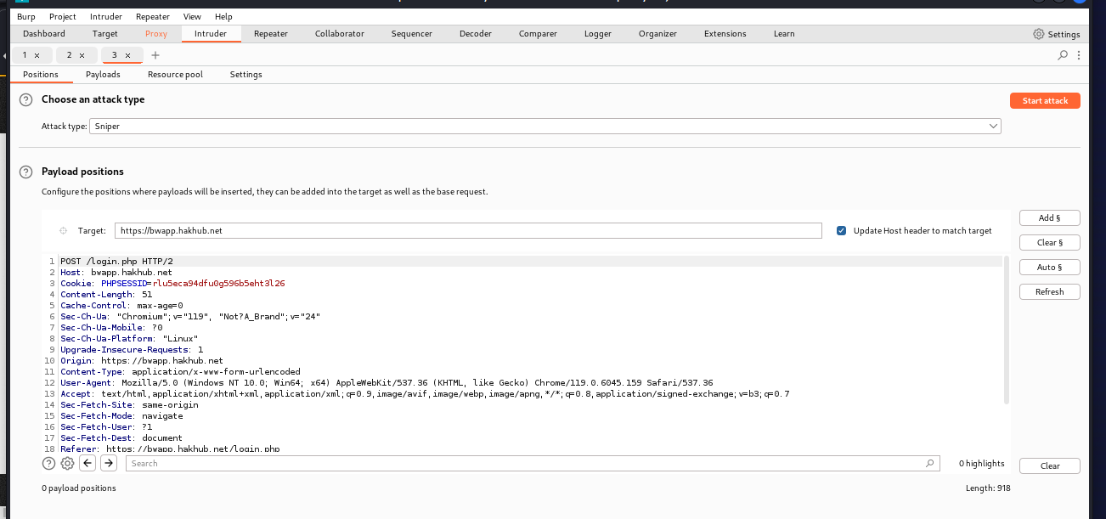

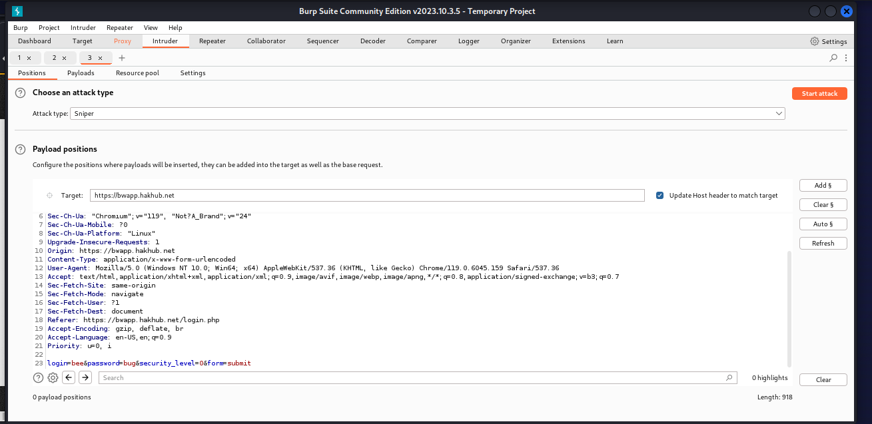

Now click Clear $

Auto $ (else position not defined mssg will come)

Then add payload   
Add <script>alert(‘Error’)</script>

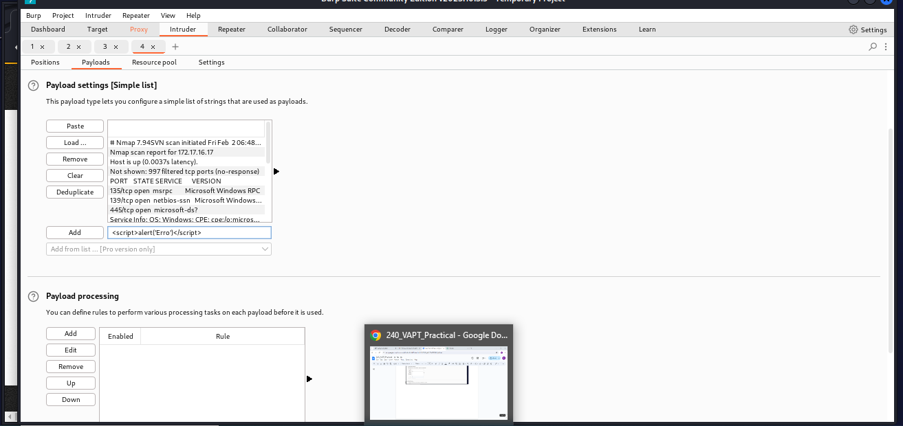

Start Attcak

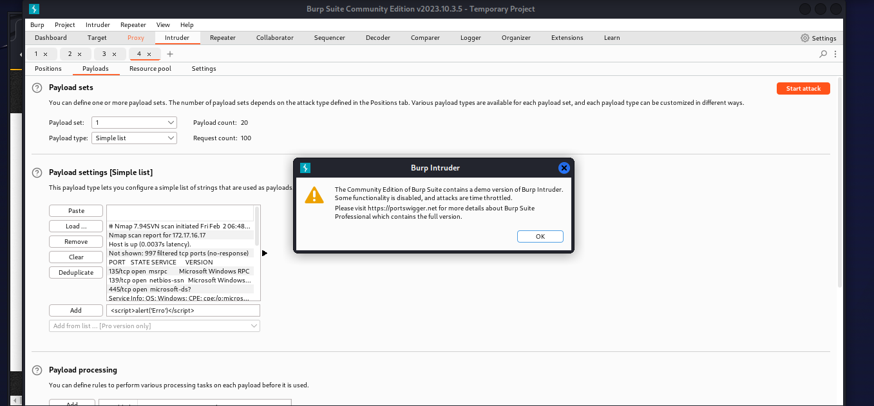

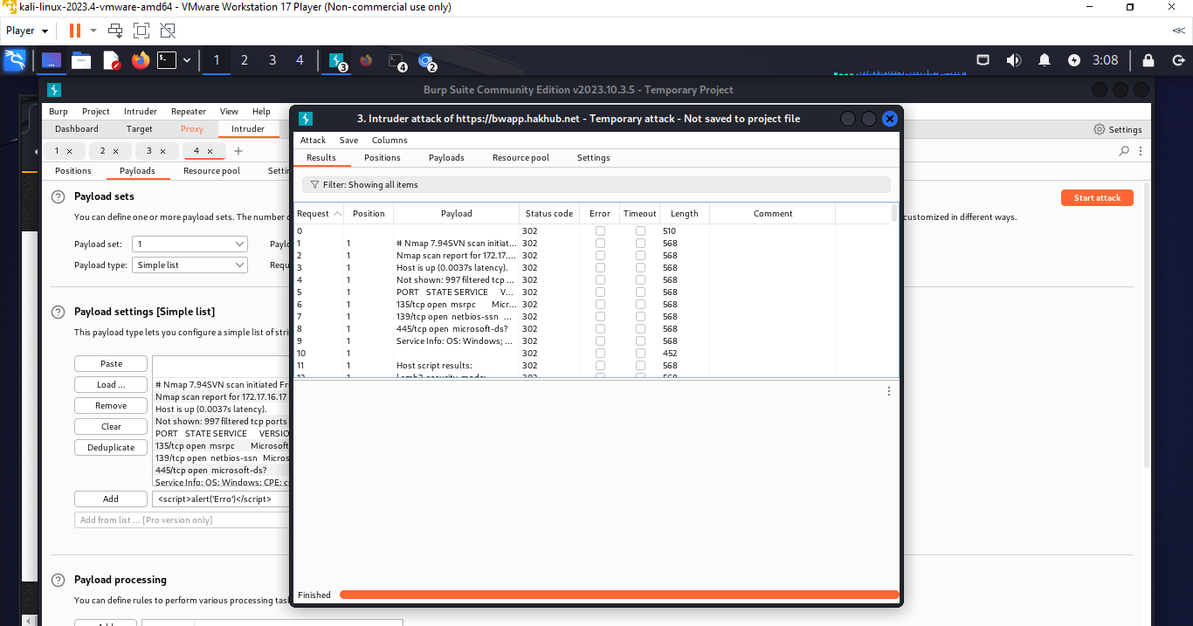

Hence, vulnerability identified and cracked



**Outcomes:**

CO4: Understand Security issues related to Software, Web and Networks.



**Conclusion: (**Conclusion to be based on the objectives and outcomes achieved**)**

Successfully implemented password cracking using Burp suite

________________________________________________________________________________________

**Grade: AA / AB / BB / BC / CC / CD /DD**

**Signature of faculty in-charge with date**

**_______________________________________________________________________________________**

**References:**

**Books/ Journals/ Websites:**

1. [**https://portswigger.net/burp/pro**](https://portswigger.net/burp/pro)
2. [**https://www.apachefriends.org/download.html**](https://www.apachefriends.org/download.html)